#
# 20190123
# Book “Kubernetes в действии”, page 66.

[belogrud@dockergate 20190123-2021]$ cat Dockerfile
FROM node:7
ADD app.js /app.js
ENTRYPOINT ["node", "app.js"]

[belogrud@dockergate 20190123-2021]$
[belogrud@dockergate 20190123-2021]$ cat app.js
const http = require('http');
const os = require('os');
console.log("Kubia server starting...");
var handler = function(request, response) {
console.log("Received request from " + request.connection.remoteAddress);
response.writeHead(200);
response.end("You've hit " + os.hostname() + "\n");
};
var www = http.createServer(handler);
www.listen(8080);
[belogrud@dockergate 20190123-2021]$

[belogrud@dockergate 20190123-2021]$ docker build -t kubia .
Sending build context to Docker daemon 46.59kB
Step 1/3 : FROM node:7
7: Pulling from library/node
ad74af05f5a2: Pull complete
2b032b8bbe8b: Pull complete
a9a5b35f6ead: Pull complete
3245b5a1c52c: Pull complete
afa075743392: Pull complete
9fb9f21641cd: Pull complete
3f40ad2666bc: Pull complete
49c0ed396b49: Pull complete
Digest: sha256:af5c2c6ac8bc3fa372ac031ef60c45a285eeba7bce9ee9ed66dad3a01e29ab8d
Status: Downloaded newer image for node:7
---> d9aed20b68a4
Step 2/3 : ADD app.js /app.js
---> d019f671a166
Step 3/3 : ENTRYPOINT ["node", "app.js"]
---> Running in ed4ecc86d1b4
Removing intermediate container ed4ecc86d1b4
---> a0f964a78114
Successfully built a0f964a78114
Successfully tagged kubia:latest
[belogrud@dockergate 20190123-2021]$

[belogrud@dockergate 20190123-2021]$ docker images
REPOSITORY TAG IMAGE ID CREATED SIZE
kubia latest a0f964a78114 6 minutes ago 660MB
hello-world latest 4ab4c602aa5e 4 months ago 1.84kB
node 7 d9aed20b68a4 17 months ago 660MB
[belogrud@dockergate 20190123-2021]$

[belogrud@dockergate 20190123-2021]$ docker run --name kubia-container -p 8080:8080 -d kubia
0589ea505a4a0d5bf82fdd8201e755792c0b2c38ea41993659e066a54b8b314b
[belogrud@dockergate 20190123-2021]$
[belogrud@dockergate 20190123-2021]$ w3m http://localhost:8080 -dump -T text/html
You've hit 0589ea505a4a
[belogrud@dockergate 20190123-2021]$
[belogrud@dockergate 20190123-2021]$ curl http://localhost:8080
You've hit 0589ea505a4a
[belogrud@dockergate 20190123-2021]$

[belogrud@dockergate 20190123-2021]$ docker ps
CONTAINER ID IMAGE COMMAND CREATED STATUS PORTS NAMES
0589ea505a4a kubia "node app.js" 3 minutes ago Up 3 minutes 0.0.0.0:8080->8080/tcp kubia-container
[belogrud@dockergate 20190123-2021]$

[belogrud@dockergate 20190123-2021]$ docker inspect kubia-container | head
[
{
"Id": "0589ea505a4a0d5bf82fdd8201e755792c0b2c38ea41993659e066a54b8b314b",
"Created": "2019-01-23T17:36:55.938512369Z",
"Path": "node",
"Args": [
"app.js"
],
"State": {
"Status": "running",
[belogrud@dockergate 20190123-2021]$

[belogrud@dockergate 20190123-2021]$ docker exec -it kubia-container bash
root@0589ea505a4a:/# ls
app.js bin boot dev etc home lib lib64 media mnt opt proc root run sbin srv sys tmp usr var
root@0589ea505a4a:/#

# Inside container.
root@0589ea505a4a:/# ps aux
USER PID %CPU %MEM VSZ RSS TTY STAT START TIME COMMAND
root 1 0.0 2.7 614424 16808 ? Ssl 17:36 0:00 node app.js
root 11 0.0 0.3 20236 1980 pts/0 Ss 17:48 0:00 bash
root 17 0.0 0.1 17492 1136 pts/0 R+ 17:50 0:00 ps aux
root@0589ea505a4a:/#

# On a host.
[belogrud@dockergate 20190123-2021]$ ps aux | grep app[.js]
root 19993 0.0 2.7 614424 16808 ? Ssl 17:36 0:00 node app.js
[belogrud@dockergate 20190123-2021]$

[belogrud@dockergate 20190123-2021]$ docker stop kubia-container
kubia-container
[belogrud@dockergate 20190123-2021]$

[belogrud@dockergate 20190123-2021]$ docker ps -a
CONTAINER ID IMAGE COMMAND CREATED STATUS PORTS NAMES
0589ea505a4a kubia "node app.js" 21 minutes ago Exited (137) 3 minutes ago kubia-container
8e21c92cc866 hello-world "/hello" 3 weeks ago Exited (0) 3 weeks ago zen_euler
[belogrud@dockergate 20190123-2021]$

[belogrud@dockergate 20190123-2021]$ docker rm kubia-container
kubia-container
[belogrud@dockergate 20190123-2021]$ docker ps -a
CONTAINER ID IMAGE COMMAND CREATED STATUS PORTS NAMES
8e21c92cc866 hello-world "/hello" 3 weeks ago Exited (0) 3 weeks ago zen_euler
[belogrud@dockergate 20190123-2021]$

[belogrud@dockergate 20190123-2021]$ docker tag kubia belogrud/kubia
[belogrud@dockergate 20190123-2021]$ docker images
REPOSITORY TAG IMAGE ID CREATED SIZE
kubia latest a0f964a78114 33 minutes ago 660MB
belogrud/kubia latest a0f964a78114 33 minutes ago 660MB
hello-world latest 4ab4c602aa5e 4 months ago 1.84kB
node 7 d9aed20b68a4 17 months ago 660MB
[belogrud@dockergate 20190123-2021]$

# Before push image, it’s require to login into docker hub with command:
# docker login
[belogrud@dockergate 20190123-2021]$ docker push belogrud/kubia
The push refers to repository [docker.io/belogrud/kubia]
12b3852de1d7: Pushed
ab90d83fa34a: Mounted from library/node
8ee318e54723: Mounted from library/node
e6695624484e: Mounted from library/node
da59b99bbd3b: Mounted from library/node
5616a6292c16: Mounted from library/node
f3ed6cb59ab0: Mounted from library/node
654f45ecb7e3: Mounted from library/node
2c40c66f7667: Mounted from library/node
latest: digest: sha256:b6b28e38f9dd2f69bd0c5b81721032a65735596cb40990cf7081228906e3f3bd size: 2213
[belogrud@dockergate 20190123-2021]$

#
# Here is how to run my docker container on differ host.
#
[belogrud@admingate ~]$ docker run -p 8080:8080 -d belogrud/kubia
Unable to find image 'belogrud/kubia:latest' locally
latest: Pulling from belogrud/kubia
ad74af05f5a2: Pull complete
2b032b8bbe8b: Pull complete
a9a5b35f6ead: Pull complete
3245b5a1c52c: Pull complete
afa075743392: Pull complete
9fb9f21641cd: Pull complete
3f40ad2666bc: Pull complete
49c0ed396b49: Pull complete
ae8894643f60: Pull complete
Digest: sha256:b6b28e38f9dd2f69bd0c5b81721032a65735596cb40990cf7081228906e3f3bd
Status: Downloaded newer image for belogrud/kubia:latest
8d0049d4ed72b608184242396fc8b8308c25ba75dd53ba9ffd91166d33e7a4e8
[belogrud@admingate ~]$ curl localhost:8080
You've hit 8d0049d4ed72
[belogrud@admingate ~]$
[belogrud@admingate ~]$ docker ps
CONTAINER ID IMAGE COMMAND CREATED STATUS PORTS NAMES
8d0049d4ed72 belogrud/kubia "node app.js" 55 seconds ago Up 53 seconds 0.0.0.0:8080->8080/tcp elated_diffie
[belogrud@admingate ~]$ docker stop elated_diffie
elated_diffie
[belogrud@admingate ~]$

[belogrud@admingate ~]$ docker rm elated_diffie
elated_diffie
[belogrud@admingate ~]$ docker images
REPOSITORY TAG IMAGE ID CREATED SIZE
belogrud/kubia latest a0f964a78114 About an hour ago 660MB
belogrud/otus-reddit 1.0 f3de4e197ff5 3 weeks ago 683MB
yourname/ubuntu-tmp-file latest 970ed598b0e1 4 weeks ago 116MB
ubuntu 16.04 a51debf7e1eb 2 months ago 116MB
hello-world latest 4ab4c602aa5e 4 months ago 1.84kB
[belogrud@admingate ~]$ docker rmi a0f964a78114
Untagged: belogrud/kubia:latest
Untagged: belogrud/kubia@sha256:b6b28e38f9dd2f69bd0c5b81721032a65735596cb40990cf7081228906e3f3bd
Deleted: sha256:a0f964a7811443ab697f0c6f743d3c91fa06c63caa8ba30b4625b68ab95ed0d6
Deleted: sha256:3906b60f95c6ed3ffe06fbe288f89072a2b4cbd2f981f749f64cdedfe4fd2990
Deleted: sha256:232d9f7dab8a171d77502a32208fa9e90cba5b1f2e5b4d5e8f4380a56f13dc9c
Deleted: sha256:f280ca36df30f308eba189508d214027b9ef0ebbd3f701566bcf8d87e7627531
Deleted: sha256:84e040a3b39dd8533febf65709350ef282b5f8edb3a2d3e20fe41f626841166e
Deleted: sha256:48aede9d5b2dd3ed037ce61b66e64bb398b69a342aaa191ad02cd00204f97281
Deleted: sha256:fd842df589c9dce7e7dfc5d45daf7ea907367642ddb8ca9eaa4d3c729fa9e912
Deleted: sha256:63102ff996737f31e062250371c0dd77387910c5c146496600b4cfb20db5a90d
Deleted: sha256:5d6bba18f7b25c9b93d3cc0d93a4cff54eb88b0ba22ed867633a21fc3ded5f57
Deleted: sha256:2c40c66f7667aefbb18f7070cf52fae7abbe9b66e49b4e1fd740544e7ceaebdc
[belogrud@admingate ~]$

[belogrud@admingate ~]$ docker images
REPOSITORY TAG IMAGE ID CREATED SIZE
belogrud/otus-reddit 1.0 f3de4e197ff5 3 weeks ago 683MB
yourname/ubuntu-tmp-file latest 970ed598b0e1 4 weeks ago 116MB
ubuntu 16.04 a51debf7e1eb 2 months ago 116MB
hello-world latest 4ab4c602aa5e 4 months ago 1.84kB
[belogrud@admingate ~]$

#
# Here is unsuccessful attempt to install minikube (kubernetes).
# This is on Google Cloud Engine.
#
[belogrud@dockergate 20190123-2021]$ curl -LO https://storage.googleapis.com/minikube/releases/latest/minikube-linux-amd64 && sudo install minikube-linux-amd64 /usr/local/bin/minikube
% Total % Received % Xferd Average Speed Time Time Time Current
Dload Upload Total Spent Left Speed
100 37.3M 100 37.3M 0 0 22.4M 0 0:00:01 0:00:01 --:--:-- 22.4M
[belogrud@dockergate 20190123-2021]$ minikube start
Starting local Kubernetes v1.13.2 cluster...
Starting VM...
Downloading Minikube ISO
181.48 MB / 181.48 MB [============================================] 100.00% 0s
E0124 15:36:21.854771 9432 start.go:205] Error starting host: Error creating host: Error executing step: Running precreate checks.
: VBoxManage not found. Make sure VirtualBox is installed and VBoxManage is in the path.

Retrying.
E0124 15:36:21.855151 9432 start.go:211] Error starting host: Error creating host: Error executing step: Running precreate checks.
: VBoxManage not found. Make sure VirtualBox is installed and VBoxManage is in the path
================================================================================
An error has occurred. Would you like to opt in to sending anonymized crash
information to minikube to help prevent future errors?

To disable this prompt, run: 'minikube config set WantReportErrorPrompt false'
================================================================================
Please enter your response [Y/n]: Prompt timed out.
Bummer, perhaps next time!
minikube failed :( exiting with error code 1
[belogrud@dockergate 20190123-2021]$

#
# Here is unsuccessful attempt to install minikube (kubernetes).
# This is on my VirtualBox machine.
#
[support@centos ~]$ curl -LO https://storage.googleapis.com/minikube/releases/latest/minikube-linux-amd64 && sudo install minikube-linux-amd64 /usr/local/bin/minikube
% Total % Received % Xferd Average Speed Time Time Time Current
Dload Upload Total Spent Left Speed
100 37.3M 100 37.3M 0 0 4071k 0 0:00:09 0:00:09 --:--:-- 9874k
[sudo] password for support:
[support@centos ~]$ sudo -i
[root@centos ~]# logout
[support@centos ~]$ minikube start
========================================
kubectl could not be found on your path. kubectl is a requirement for using minikube
To install kubectl, please run the following:

curl -Lo kubectl https://storage.googleapis.com/kubernetes-release/release/v1.13.2/bin/linux/amd64/kubectl && chmod +x kubectl && sudo cp kubectl /usr/local/bin/ && rm kubectl

To disable this message, run the following:

minikube config set WantKubectlDownloadMsg false
========================================
Starting local Kubernetes v1.13.2 cluster...
Starting VM...
Downloading Minikube ISO
181.48 MB / 181.48 MB [============================================] 100.00% 0s
E0124 18:46:36.539413 15744 start.go:205] Error starting host: Error creating host: Error executing step: Running precreate checks.
: VBoxManage not found. Make sure VirtualBox is installed and VBoxManage is in the path.

Retrying.
E0124 18:46:36.539752 15744 start.go:211] Error starting host: Error creating host: Error executing step: Running precreate checks.
: VBoxManage not found. Make sure VirtualBox is installed and VBoxManage is in the path
================================================================================
An error has occurred. Would you like to opt in to sending anonymized crash
information to minikube to help prevent future errors?

To disable this prompt, run: 'minikube config set WantReportErrorPrompt false'
================================================================================
Please enter your response [Y/n]: Y

minikube failed :( exiting with error code 1
[support@centos ~]$

https://github.com/kubernetes/minikube
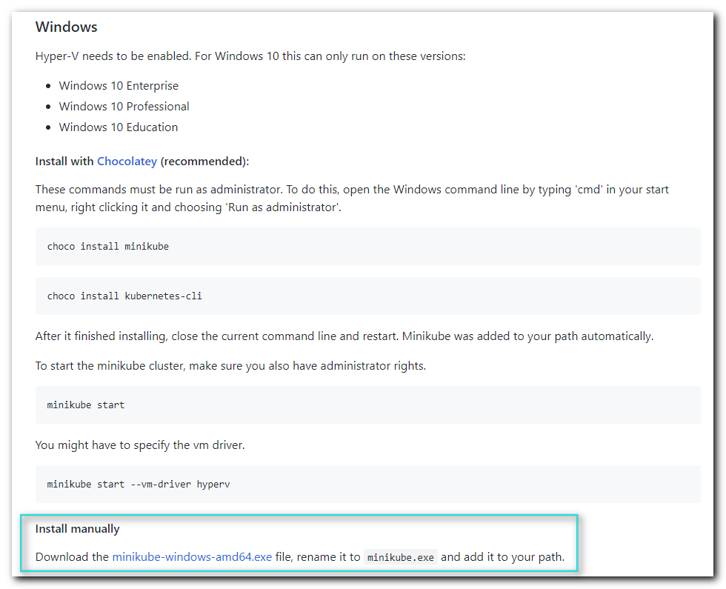

#
# I’ve renamed file to minikube.exe, run cmd in directory, where this file placed and run follow command.
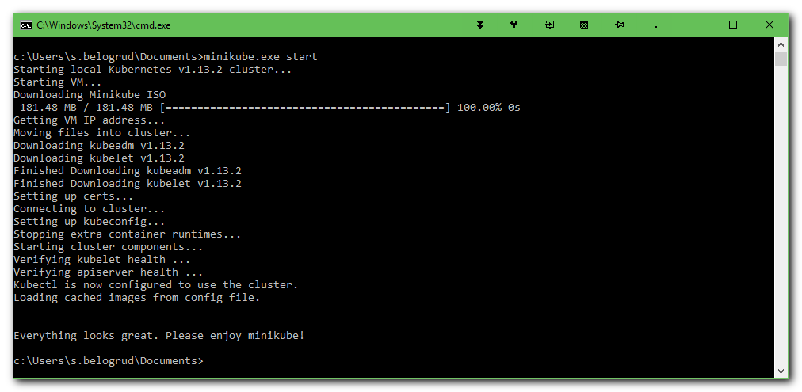
c:\Users\s.belogrud\Documents>minikube.exe start
Starting local Kubernetes v1.13.2 cluster...
Starting VM...
Downloading Minikube ISO
181.48 MB / 181.48 MB [============================================] 100.00% 0s
Getting VM IP address...
Moving files into cluster...
Downloading kubeadm v1.13.2
Downloading kubelet v1.13.2
Setting up certs...
Connecting to cluster...
Setting up kubeconfig...
Stopping extra container runtimes...
Starting cluster components...
Verifying kubelet health ...
Verifying apiserver health ...
Kubectl is now configured to use the cluster.
Loading cached images from config file.

Everything looks great. Please enjoy minikube!

c:\Users\s.belogrud\Documents>

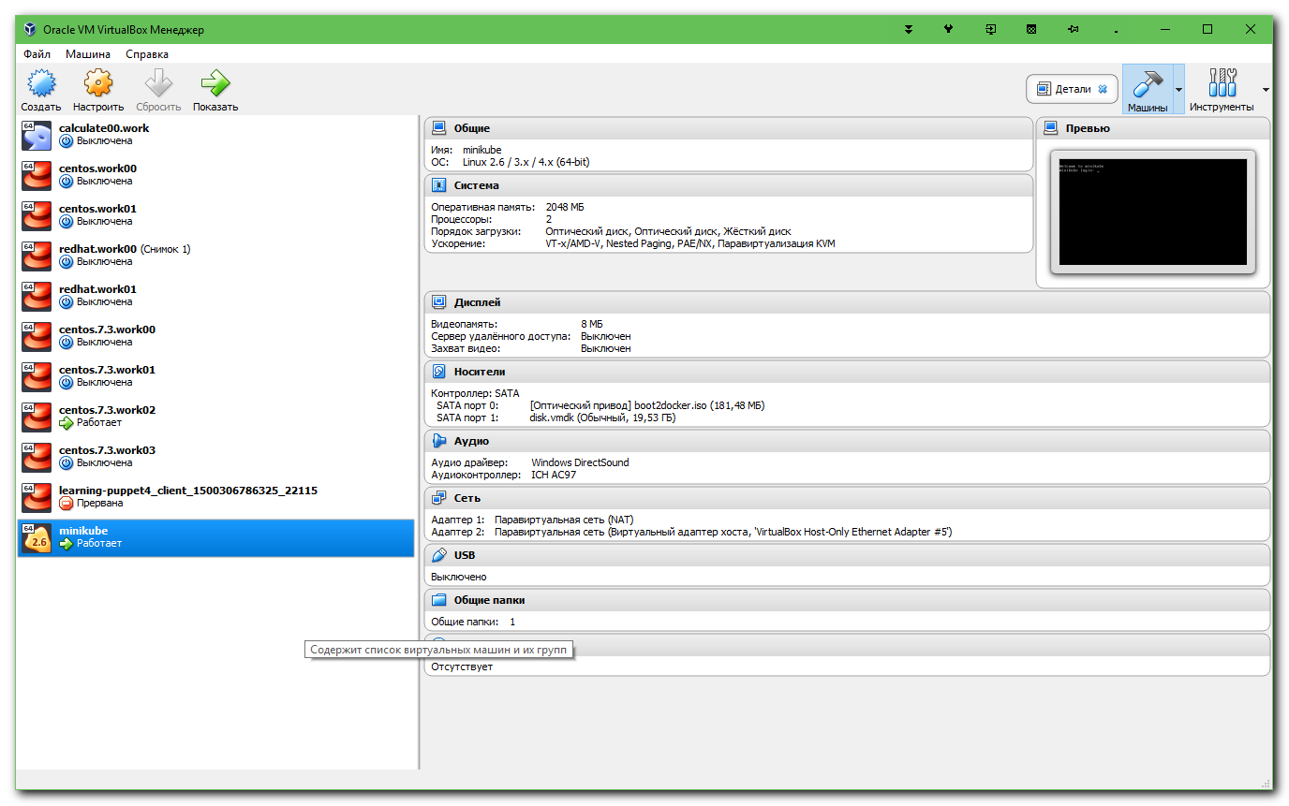

https://kubernetes.io/docs/tasks/tools/install-kubectl/
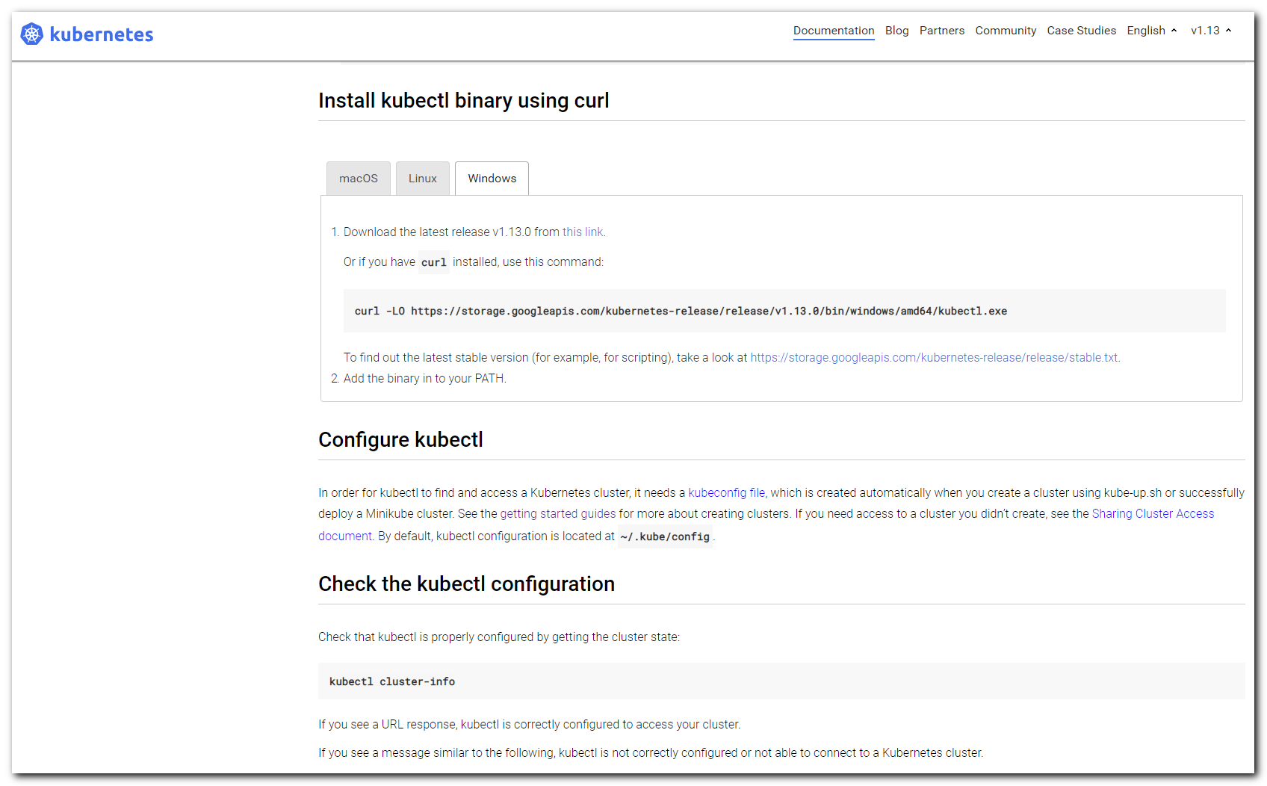

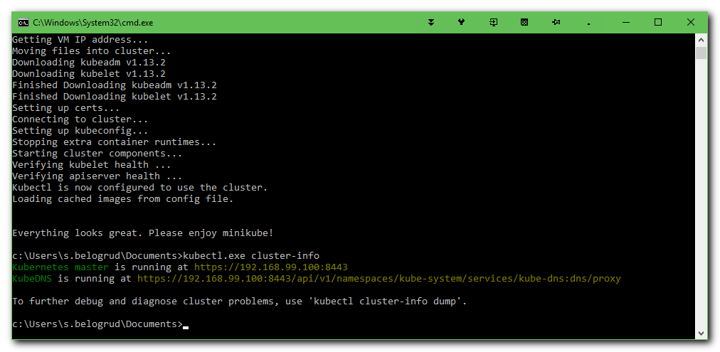
c:\Users\s.belogrud\Documents>kubectl.exe cluster-info
Kubernetes master is running at https://192.168.99.100:8443
KubeDNS is running at https://192.168.99.100:8443/api/v1/namespaces/kube-system/services/kube-dns:dns/proxy

To further debug and diagnose cluster problems, use 'kubectl cluster-info dump'.

c:\Users\s.belogrud\Documents>

c:\Users\s.belogrud\Documents>dir ..\.kube
Том в устройстве C не имеет метки.
Серийный номер тома: 1004-B578

Содержимое папки c:\Users\s.belogrud\.kube

24.01.2019 19:25 <DIR> .
24.01.2019 19:25 <DIR> ..
24.01.2019 19:25 <DIR> cache
24.01.2019 18:57 445 config
24.01.2019 19:25 <DIR> http-cache
1 файлов 445 байт
4 папок 79 106 232 320 байт свободно

c:\Users\s.belogrud\Documents>

c:\Users\s.belogrud\Documents>type ..\.kube\config
apiVersion: v1
clusters:
- cluster:
certificate-authority: C:\Users\s.belogrud\.minikube\ca.crt
server: https://192.168.99.100:8443
name: minikube
contexts:
- context:
cluster: minikube
user: minikube
name: minikube
current-context: minikube
kind: Config
preferences: {}
users:
- name: minikube
user:
client-certificate: C:\Users\s.belogrud\.minikube\client.crt
client-key: C:\Users\s.belogrud\.minikube\client.key

c:\Users\s.belogrud\Documents>

#
# I’ve created a directory.
c:\Users\s.belogrud\Documents>cd kubernetes

c:\Users\s.belogrud\Documents\kubernetes>dir
Том в устройстве C не имеет метки.
Серийный номер тома: 1004-B578

Содержимое папки c:\Users\s.belogrud\Documents\kubernetes

24.01.2019 19:31 <DIR> .
24.01.2019 19:31 <DIR> ..
24.01.2019 19:24 39 644 160 kubectl.exe
24.01.2019 18:51 39 061 504 minikube.exe
2 файлов 78 705 664 байт
2 папок 79 100 837 888 байт свободно

c:\Users\s.belogrud\Documents\kubernetes>

c:\Users\s.belogrud\Documents\kubernetes>minikube.exe ssh
_ _
_ _ ( ) ( )
___ ___ (_) ___ (_)| |/') _ _ | |_ __
/' _ ` _ `\| |/' _ `\| || , < ( ) ( )| '_`\ /'__`\
| ( ) ( ) || || ( ) || || |\`\ | (_) || |_) )( ___/
(_) (_) (_)(_)(_) (_)(_)(_) (_)`\___/'(_,__/'`\____)

$ uname -a
Linux minikube 4.15.0 #1 SMP Fri Jan 18 22:39:33 UTC 2019 x86_64 GNU/Linux
$ exit
logout

c:\Users\s.belogrud\Documents\kubernetes>

[belogrud@dockergate 20190123-2021]$ gcloud container clusters create kubia --num-nodes 3 --machine-type f1-micro
WARNING: Starting in 1.12, new clusters will have basic authentication disabled by default. Basic authentication can be enabled (or disabled) manually using the `--[no-]enable-basic-auth` flag.
WARNING: Starting in 1.12, new clusters will not have a client certificate issued. You can manually enable (or disable) the issuance of the client certificate using the `--[no-]issue-client-certificate` flag.
WARNING: Currently VPC-native is not the default mode during cluster creation. In the future, this will become the default mode and can be disabled using `--no-enable-ip-alias` flag. Use `--[no-]enable-ip-alias` flag to suppress this warning.
WARNING: Starting in 1.12, default node pools in new clusters will have their legacy Compute Engine instance metadata endpoints disabled by default. To create a cluster with legacy instance metadata endpoints disabled in the default node pool, run `clusters create` with the flag `--metadata disable-legacy-endpoints=true`.
This will enable the autorepair feature for nodes. Please see https://cloud.google.com/kubernetes-engine/docs/node-auto-repair for more information on node autorepairs.
WARNING: Starting in Kubernetes v1.10, new clusters will no longer get compute-rw and storage-ro scopes added to what is specified in --scopes (though the latter will remain included in the default --scopes). To use these scopes, add them explicitly to --scopes. To use the new behavior, set container/new_scopes_behavior property (gcloud config set container/new_scopes_behavior true).
ERROR: (gcloud.container.clusters.create) ResponseError: code=403, message=Kubernetes Engine API is not enabled for this project. Please ensure it is enabled in Google Cloud Console and try again: visit https://console.cloud.google.com/apis/api/container.googleapis.com/overview?project=docker-226812 to do so.
[belogrud@dockergate 20190123-2021]$

https://console.cloud.google.com/apis/library/container.googleapis.com?project=docker-226812
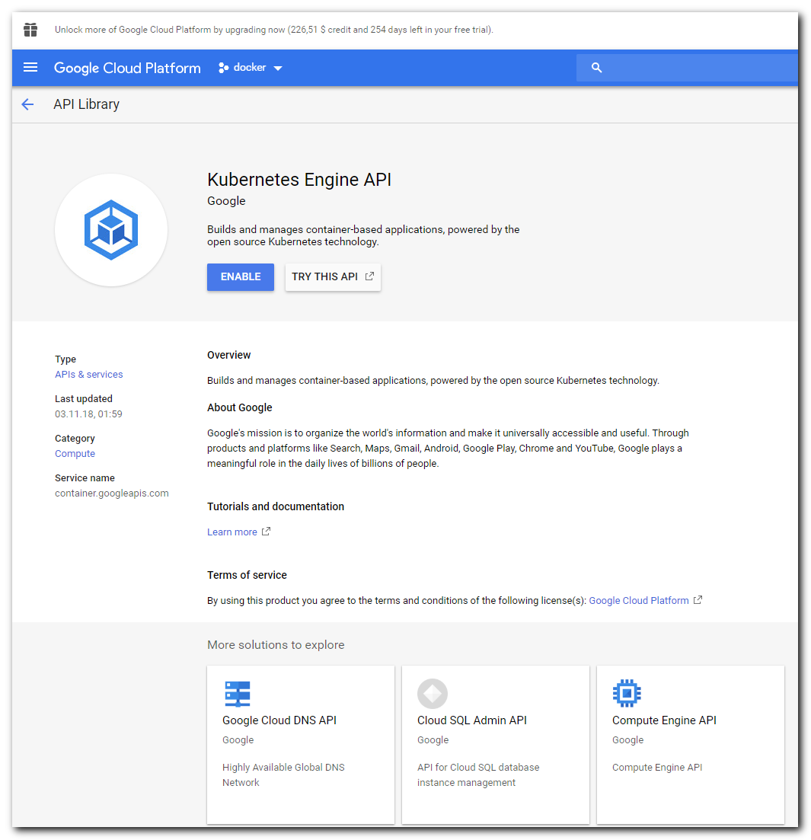

# Button “Enable” has been pressed.
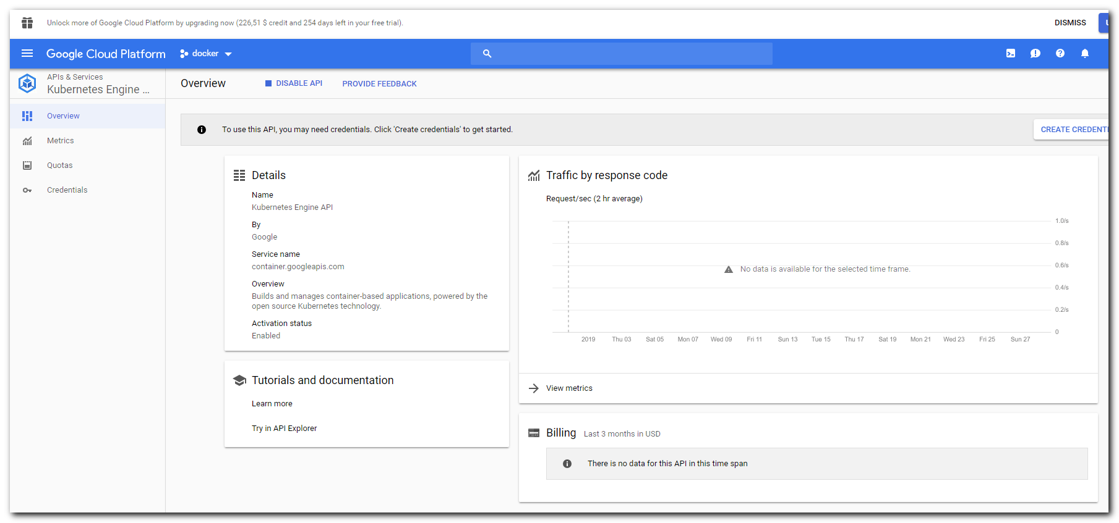

[belogrud@dockergate 20190123-2021]$ gcloud container clusters create kubia --num-nodes 3 --machine-type f1-micro
WARNING: Starting in 1.12, new clusters will have basic authentication disabled by default. Basic authentication can be enabled (or disabled) manually using the `--[no-]enable-basic-auth` flag.
WARNING: Starting in 1.12, new clusters will not have a client certificate issued. You can manually enable (or disable) the issuance of the client certificate using the `--[no-]issue-client-certificate` flag.
WARNING: Currently VPC-native is not the default mode during cluster creation. In the future, this will become the default mode and can be disabled using `--no-enable-ip-alias` flag. Use `--[no-]enable-ip-alias` flag to suppress this warning.
WARNING: Starting in 1.12, default node pools in new clusters will have their legacy Compute Engine instance metadata endpoints disabled by default. To create a cluster with legacy instance metadata endpoints disabled in the default node pool, run `clusters create` with the flag `--metadata disable-legacy-endpoints=true`.
This will enable the autorepair feature for nodes. Please see https://cloud.google.com/kubernetes-engine/docs/node-auto-repair for more information on node autorepairs.
WARNING: Starting in Kubernetes v1.10, new clusters will no longer get compute-rw and storage-ro scopes added to what is specified in --scopes (though the latter will remain included in the default --scopes). To use these scopes, add them explicitly to --scopes. To use the new behavior, set container/new_scopes_behavior property (gcloud config set container/new_scopes_behavior true).
Creating cluster kubia in europe-west2-a... Cluster is being health-checked (master is healthy)...done.
Created [https://container.googleapis.com/v1/projects/docker-226812/zones/europe-west2-a/clusters/kubia].
To inspect the contents of your cluster, go to: https://console.cloud.google.com/kubernetes/workload_/gcloud/europe-west2-a/kubia?project=docker-226812
kubeconfig entry generated for kubia.
NAME LOCATION MASTER_VERSION MASTER_IP MACHINE_TYPE NODE_VERSION NUM_NODES STATUS
kubia europe-west2-a 1.10.11-gke.1 35.189.103.225 f1-micro 1.10.11-gke.1 3 RUNNING
[belogrud@dockergate 20190123-2021]$

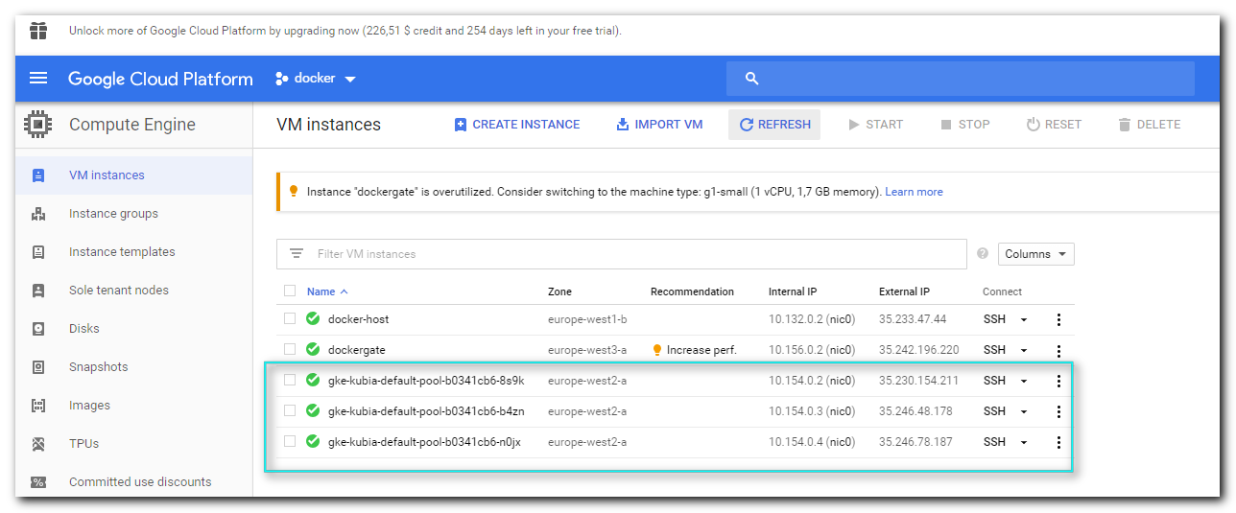

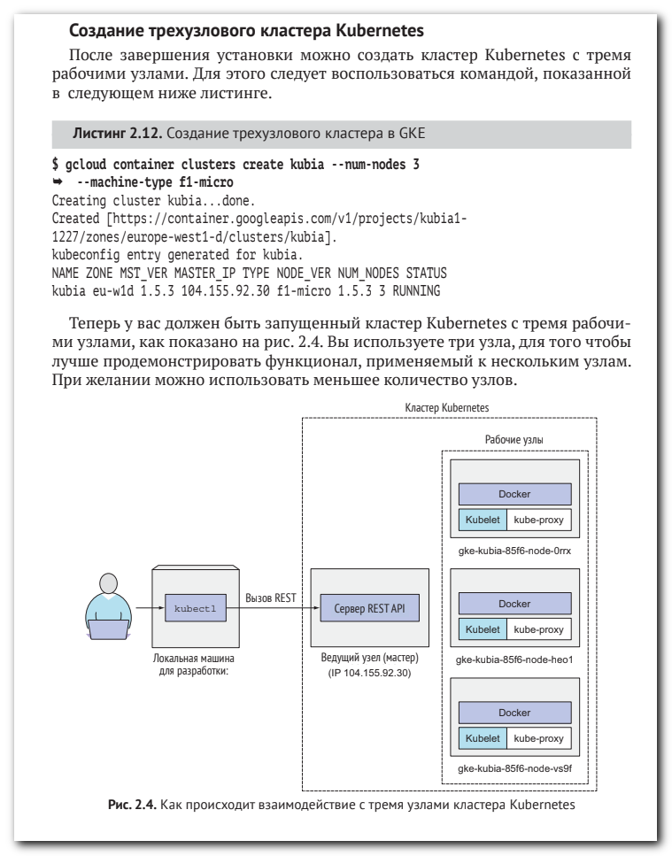

[belogrud@dockergate 20190123-2021]$ kubectl get nodes
NAME STATUS ROLES AGE VERSION
gke-kubia-default-pool-b0341cb6-8s9k Ready <none> 4m v1.10.11-gke.1
gke-kubia-default-pool-b0341cb6-b4zn Ready <none> 4m v1.10.11-gke.1
gke-kubia-default-pool-b0341cb6-n0jx Ready <none> 4m v1.10.11-gke.1
[belogrud@dockergate 20190123-2021]$

[belogrud@dockergate 20190123-2021]$ gcloud compute ssh gke-kubia-default-pool-b0341cb6-8s9k
WARNING: The public SSH key file for gcloud does not exist.
WARNING: The private SSH key file for gcloud does not exist.
WARNING: You do not have an SSH key for gcloud.
WARNING: SSH keygen will be executed to generate a key.
Generating public/private rsa key pair.
Enter passphrase (empty for no passphrase):
Enter same passphrase again:
Your identification has been saved in /home/belogrud/.ssh/google_compute_engine.
Your public key has been saved in /home/belogrud/.ssh/google_compute_engine.pub.
The key fingerprint is:
SHA256:1L/+ibh7beTKsk7rdt/is6D/X/2BZ5V+n83gkYFNSGI belogrud@dockergate
The key's randomart image is:
+---[RSA 2048]----+
| E . |
| o o . |
| . . . . |
| . . + .|
| S o o..|
| .+oo|
| . o=+=+|
| .o*o+O*O|
| +XO*BO*B|
+----[SHA256]-----+
Updating project ssh metadata...⠛Updated [https://www.googleapis.com/compute/v1/projects/docker-226812].
Updating project ssh metadata...done.
Waiting for SSH key to propagate.
Warning: Permanently added 'compute.1073100626233297677' (ED25519) to the list of known hosts.

Welcome to Kubernetes v1.10.11-gke.1!

You can find documentation for Kubernetes at:
http://docs.kubernetes.io/

The source for this release can be found at:
/home/kubernetes/kubernetes-src.tar.gz
Or you can download it at:
https://storage.googleapis.com/kubernetes-release-gke/release/v1.10.11-gke.1/kubernetes-src.tar.gz

It is based on the Kubernetes source at:
https://github.com/kubernetes/kubernetes/tree/v1.10.11-gke.1

For Kubernetes copyright and licensing information, see:
/home/kubernetes/LICENSES

belogrud@gke-kubia-default-pool-b0341cb6-8s9k ~ $

belogrud@gke-kubia-default-pool-b0341cb6-8s9k ~ $ whoami
belogrud
belogrud@gke-kubia-default-pool-b0341cb6-8s9k ~ $ ip -f inet addr | grep inet
inet 127.0.0.1/8 scope host lo
inet 10.154.0.2/32 brd 10.154.0.2 scope global dynamic eth0
inet 169.254.123.1/24 scope global docker0
inet 10.60.0.1/24 scope global cbr0
belogrud@gke-kubia-default-pool-b0341cb6-8s9k ~ $

[belogrud@dockergate 20190123-2021]$ kubectl describe node gke-kubia-default-pool-b0341cb6-8s9k
Name: gke-kubia-default-pool-b0341cb6-8s9k
Roles: <none>
Labels: beta.kubernetes.io/arch=amd64
beta.kubernetes.io/fluentd-ds-ready=true
beta.kubernetes.io/instance-type=f1-micro
beta.kubernetes.io/os=linux
cloud.google.com/gke-nodepool=default-pool
cloud.google.com/gke-os-distribution=cos
failure-domain.beta.kubernetes.io/region=europe-west2
failure-domain.beta.kubernetes.io/zone=europe-west2-a
kubernetes.io/hostname=gke-kubia-default-pool-b0341cb6-8s9k
Annotations: node.alpha.kubernetes.io/ttl: 0
volumes.kubernetes.io/controller-managed-attach-detach: true
CreationTimestamp: Mon, 28 Jan 2019 17:05:15 +0000
Taints: <none>
Unschedulable: false
Conditions:
Type Status LastHeartbeatTime LastTransitionTime Reason M
essage
---- ------ ----------------- ------------------ ------ -
------
ReadonlyFilesystem
...

[belogrud@dockergate 20190123-2021]$ kubectl top nodes
NAME CPU(cores) CPU% MEMORY(bytes) MEMORY%
gke-kubia-default-pool-b0341cb6-8s9k 36m 3% 383Mi 65%
gke-kubia-default-pool-b0341cb6-b4zn <unknown> <unknown> <unknown> <unknown>
gke-kubia-default-pool-b0341cb6-n0jx <unknown> <unknown> <unknown> <unknown>
[belogrud@dockergate 20190123-2021]$

# It’s been used for auto completion on Tab for kubernetes command kubectl.
[root@admingate 20181225-1505]# yum install bash-completion
[belogrud@dockergate 20190123-2021]$ source <(kubectl completion bash)

[belogrud@dockergate 20190123-2021]$ vim ~/.bashrc
[belogrud@dockergate 20190123-2021]$ tail -n 2 ~/.bashrc
# User specific aliases and functions
kubectl completion bash
[belogrud@dockergate 20190123-2021]$

#
# Khmm - not working...
[belogrud@dockergate 20190123-2021]$ kubectl to-bash: _get_comp_words_by_ref: command not found
^C
[belogrud@dockergate 20190123-2021]$

[belogrud@dockergate 20190123-2021]$ echo 'source <(kubectl completion bash)' >> ~/.bashrc
[belogrud@dockergate 20190123-2021]$ vim ~/.bashrc
[belogrud@dockergate 20190123-2021]$ source ~/.bashrc
[belogrud@dockergate 20190123-2021]$ kubectl to-bash: _get_comp_words_by_ref: command not found
^C
[belogrud@dockergate 20190123-2021]$

[belogrud@dockergate 20190123-2021]$ kubectl run kubia --image=luksa/kubia --port=8080 --generator=run/v1
kubectl run --generator=run/v1 is DEPRECATED and will be removed in a future version. Use kubectl run --generator=run-pod/v1 or kubectl create instead.
replicationcontroller/kubia created
[belogrud@dockergate 20190123-2021]$

[belogrud@dockergate 20190123-2021]$ kubectl get pods
NAME READY STATUS RESTARTS AGE
kubia-4jvcz 0/1 ContainerCreating 0 9m
[belogrud@dockergate 20190123-2021]$

